Minitab Automation User Guide

# Requirements

* .NET Framework 4.0 must be installed to run this tool. You can go to <https://www.microsoft.com/zh-cn/download/details.aspx?id=17718> to download and install it if not installed before.
* Minitab 16 must be installed for this automation tool.
* Excel file should be total same structure with template Excel file.

# Steps of how to use this tool

1. Double click *MinitabAutomation.exe* in application folder to run this tool. If you can’t open it with error, please make sure you have .NET Framework 4.0 installed.

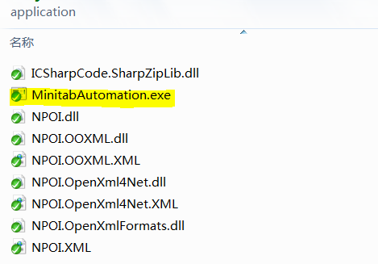

1. Click “Select” button to choose the Excel file which you want run Minitab Automation and then click “Process” button to process.

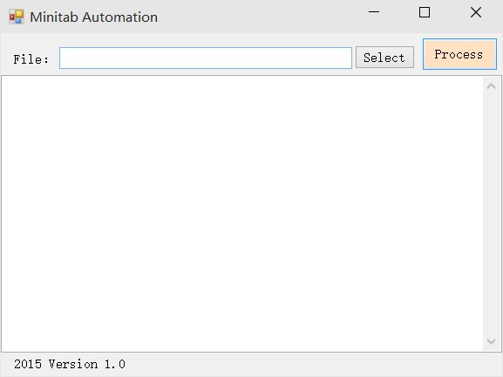

1. When this tool is running, you will see Minitab is working like below:

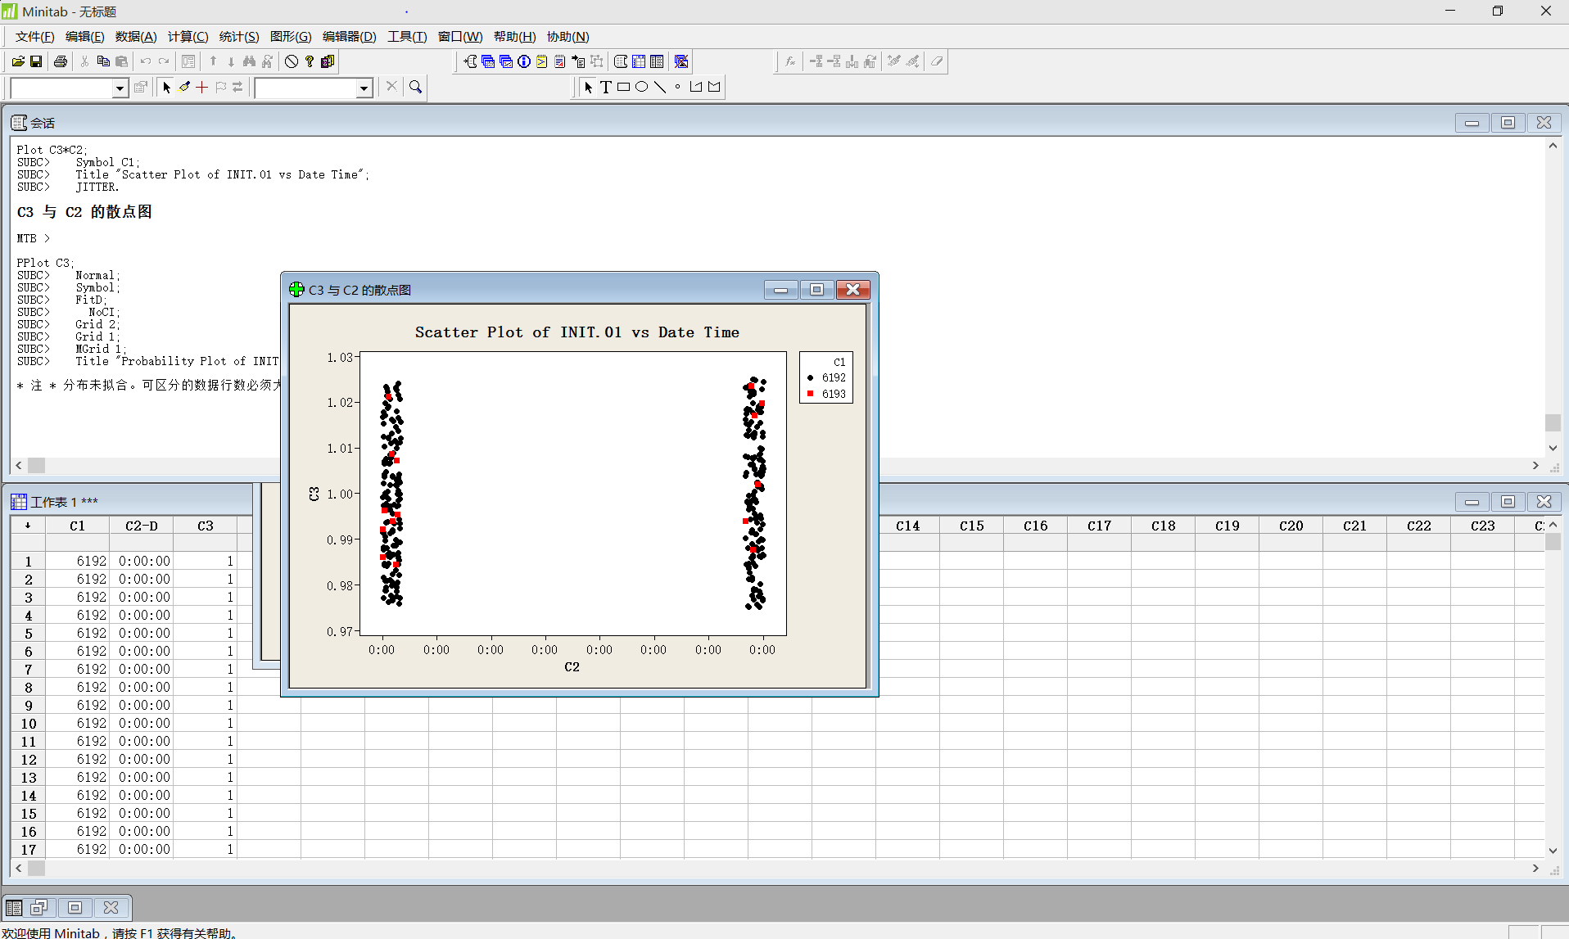

1. When you see below popup message, it means all process are done.

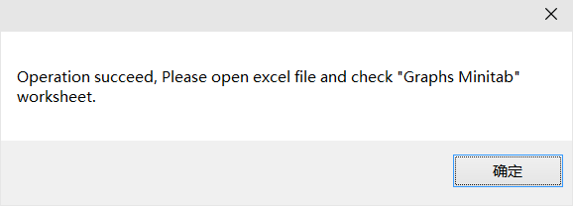

# Outputs

* In the source Excel, sheet “Graphs Minitab” is added which contains all reports.

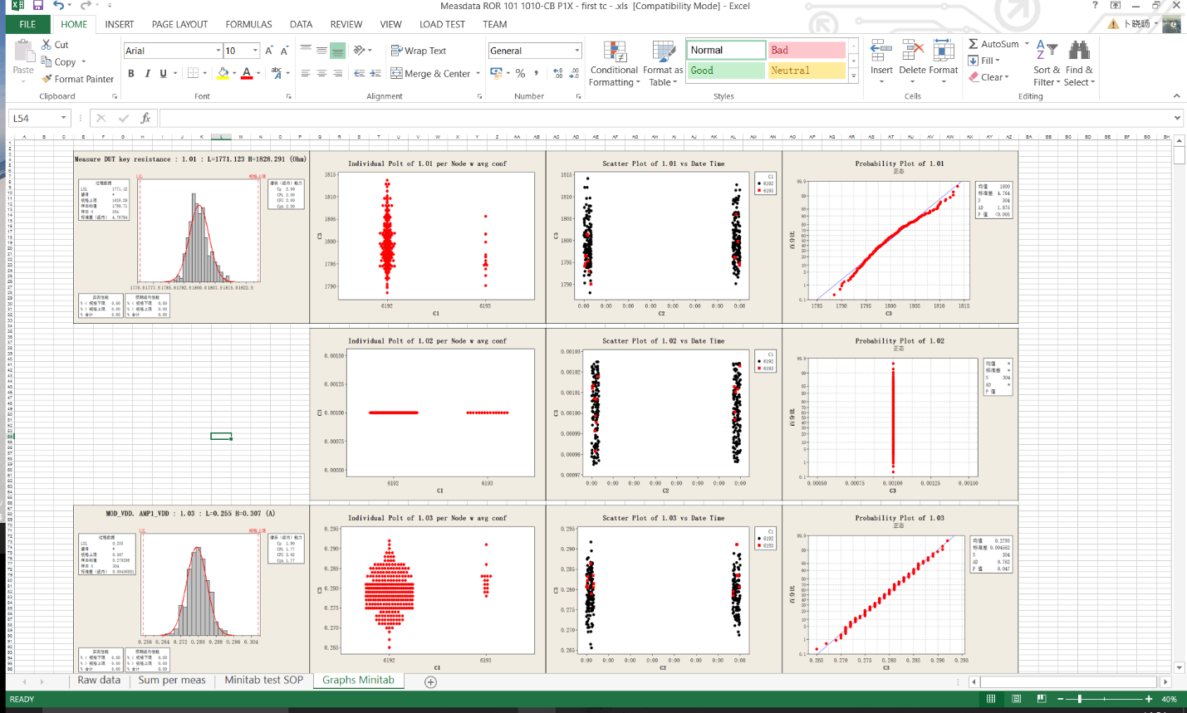

* In same folder with Excel file, new image folder is created which contains all reports image also.

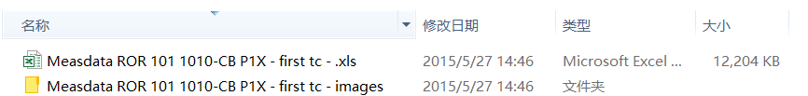

Files in images folder:

